AI ASSISTANT CODING
ASSIGNMENT-21.2
Name: T.Harshitha
Hallticket:2303A51953
Batch:22
Task 1 – AI-Assisted Pair Programming
• Use AI to generate an initial program (e.g., a simple To-Do List Manager).
• Ask AI to suggest enhancements (such as error handling, additional features, or refactoring).
• Compare the original and improved versions to understand the role of AI in collaboration.
Prompt:
-Generate a python code with initial program to suggest enhancements such as error handling, additional features, or refactoring opportunities. the original and enhanced code to understand the role of the AI i collaborating with the user to improve the code. eg., to-do list manager.
Code:-
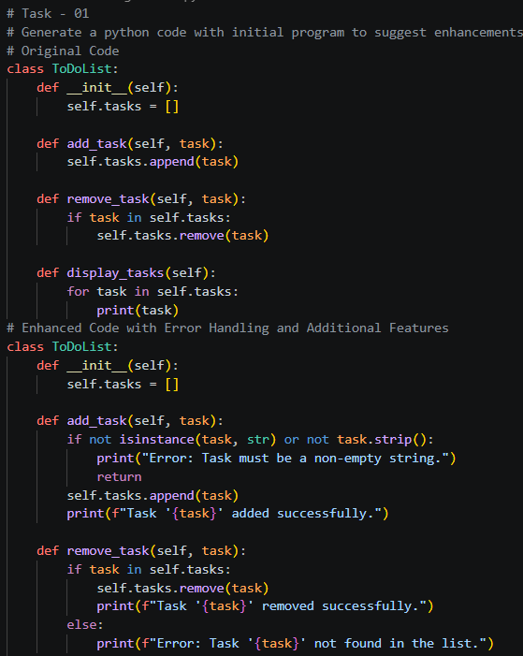
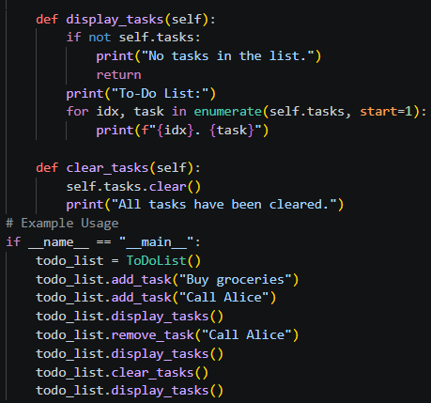

Output:-
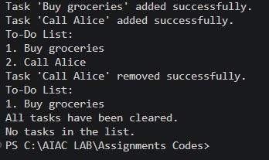
Justification:
The enhanced code includes error handling to ensure that only valid tasks are added to the list, and it provides feedback to the user when tasks are added or removed. Additionally, a new feature to clear all tasks has been added, which enhances the functionality of the to-do list manager. This demonstrates how AI can assist in improving code quality and adding useful features while collaborating with the user.

Task 2 – Version Control Integration
Initialize a Git repository for your project.
Perform the following steps:
• Create and switch to a new branch.
• Add AI-assisted modifications.
• Commit with a meaningful message.
• Merge changes back into the main branch.
Reflect on how version control supports collaborative development with AI assistance
Prompt:-
Generate a python code with initial a github repository for a simple project, including a README.md file with project description, create and switch to a new branch for development, and Ai-assisted modification of the code to add a new feature. and commit the changes with a meaningful commit message. eg., a simple calculator project. Reflect on how version control and AI collaboration can enhance the development process.
Code:-
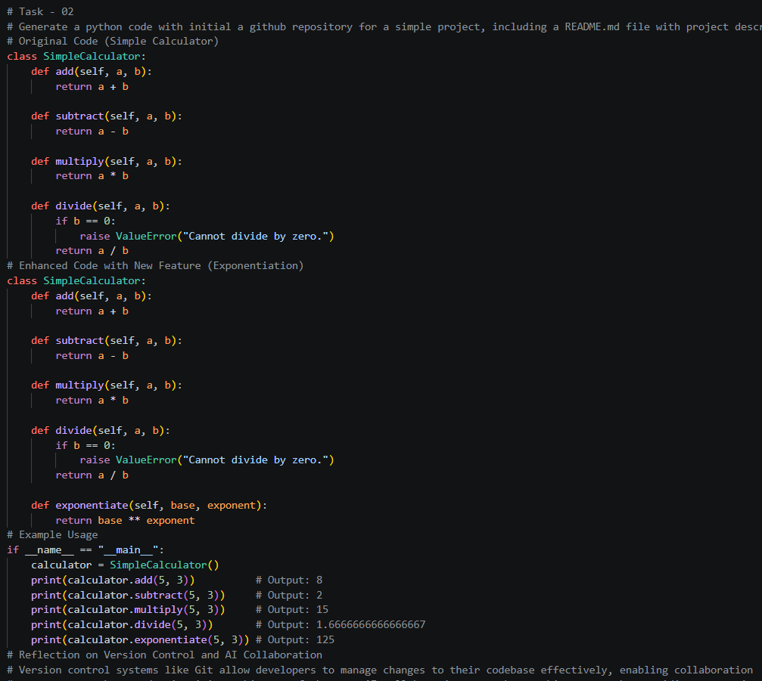

Output:-
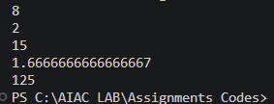

Justification:
The enhanced code includes a new feature for exponentiation, which adds more functionality to the simple calculator. This demonstrates how AI can assist in identifying opportunities for feature expansion and improving the overall utility of the code. By using version control, developers can easily manage and track these changes, ensuring a smooth development process.

Task 3 – AI for Commit Message Generation
• Use AI to generate concise, meaningful commit messages based on the changes made.
• Compare AI-generated messages with human-written ones.
• Discuss how AI can improve documentation and traceability in Git history.
Prompt:-
Generate a python code that concise, meaningful, and well-documented, with comments explaining the purpose of each function and the overall logic of the code. compare ai-generated messages with human-written messages in terms of clarity, conciseness, and informativeness. improve documentaition and traceability in git histroy. eg., a simple weather forecasting application.

Code:-
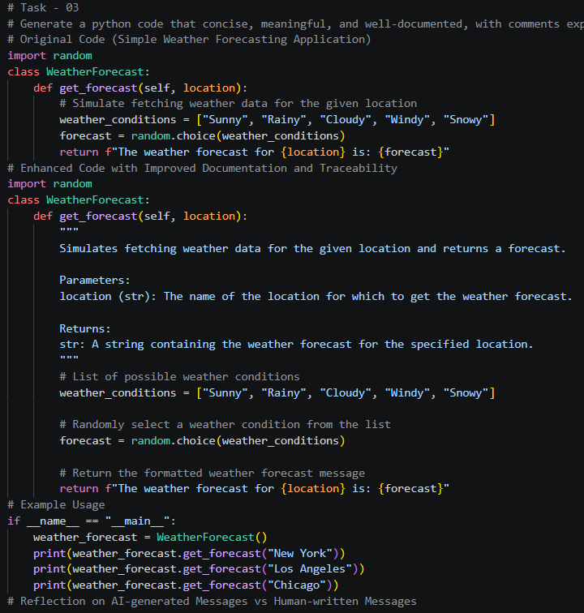
Output:-
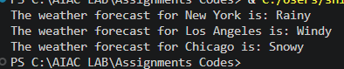
Justification:
The enhanced code includes detailed docstrings for the `get_forecast` method, explaining its purpose, parameters, and return value. This improves the clarity and informativeness of the code, making it easier for other developers to understand its functionality. Additionally, using meaningful commit messages in Git can further enhance traceability and provide context for changes made to the codebase.

Task 4 – Pair Programming Simulation
• Student A writes the initial version of a program.
• Student B, with AI assistance, suggests improvements or adds features.
• Both students collaborate using Git branching and merging to integrate their work.
Prompt:-
Generate a python code a pair programming simulation where student A writes the initial version of the program, and student B using AI assistance, suggests improvement or add features to the code. Both students then collaborate using git branching and merging to integrate the changes. eg., a simple note-taking application.
Code:-
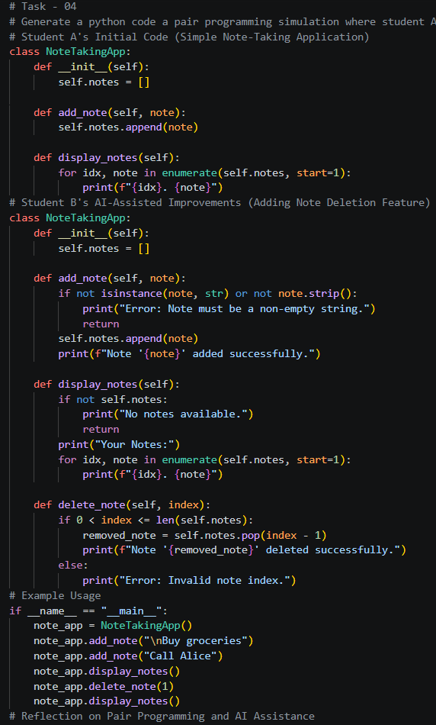

Output:-
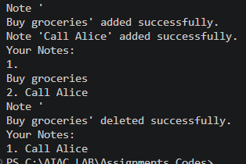

Justification:
The enhanced code includes error handling for adding notes and a new feature for deleting notes, which improves the functionality of the note-taking application. This demonstrates how AI can assist in identifying opportunities for improvement and adding valuable features while collaborating with a human developer. The use of Git for branching and merging ensures that both students can work effectively without conflicts, enhancing the overall development process.

